**\*NearWorker\***

**Problem :** Only on metro city.

**Solution :** To reach in a village area.

**NearWorker-**order from customer(people).

**Abstract:**

* Where have a repair and installing work is there house or office.
* We get the order from customer(people) then clear the problem through the application

**Types of users:**

1. Working professionals

2. Customers(people)

3. Admin

**Modules:**

**1. Professional Module:**

* The Working Professionals has to register themselves to get an insight about NearWorker.

* The Working Professionals has to select the types of memberships available with us.

* The Working Professionals can't tie up with NearWorker Customers(people)

* After selecting suitable membership they will be redirected towards the payment page.

* The Working Professionals makes the payment to become a member of NearWorker.

* A Profile will be created for the Working Professionals.

* There will be an option provided to stop the services with NearWorker.

* But, Membership amount will be not refund.

* The Working Professionals can propose their name,set a profile picture and experience about them.

* The Working Professionals will be enable for his our sutable time.

* Working Professionals will be enabled to interact with NearWorker.

* Working Professionals will be enabled with a chat to interact with customers(people).

**2.Customer Module:**

* Customers(people) has to register our mobile number.

* Customers(people) to register our details.

* Customers(people) can intract with customer care through NearWorker.

* Customers(people) can rise any complaint for working professionals.

* Customers(people) to fill the review our work.

* Customer(people) can pay through only online method(net banking,UPI,credit and debit cards).

**3.Admin Module:**

* we get the booking order process to the Working Professionals.

* Depending upon the membership and Rating we give the first priority

* Any report get from customer side we analysis the report and we take action through legally(unwanted issuse) .

* we are monitoring the Customer and Working Professionals.

**Functionalities:-**

**Workflow:**

**Professional Module:**

1.regester/signup-> get otp->conform otp->hide password->captche

2.login / sign in-> get otp->conform otp->hide password->captche

3.forgot pass word->get otp->conform otp->change password

4.membership change button

5.prifile button(update)

6.new order button

7.history button

**Customer Module:**

1.regester/signup-> get otp->conform otp->hide password->captche

2.login / sign in-> get otp->conform otp->hide password->captche

3.forgot pass word->get otp->conform otp->change password

4.booking option button.

5.booking cancel button

6.rating and review (feedback)

7.payment link

**Admin Module:**

1.verification call

2.Process button

3.review monotoring tab

**WireFrame:**

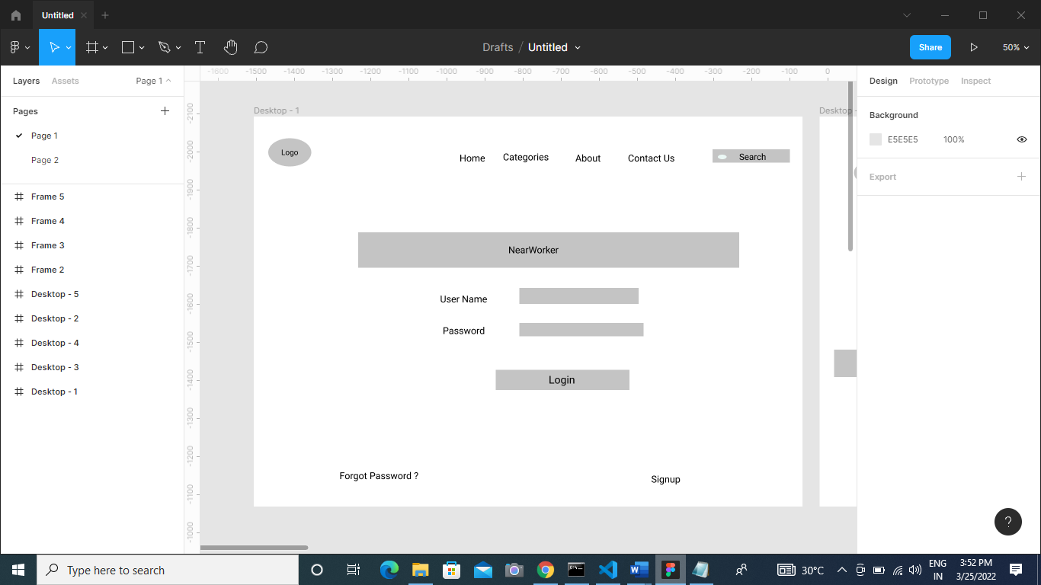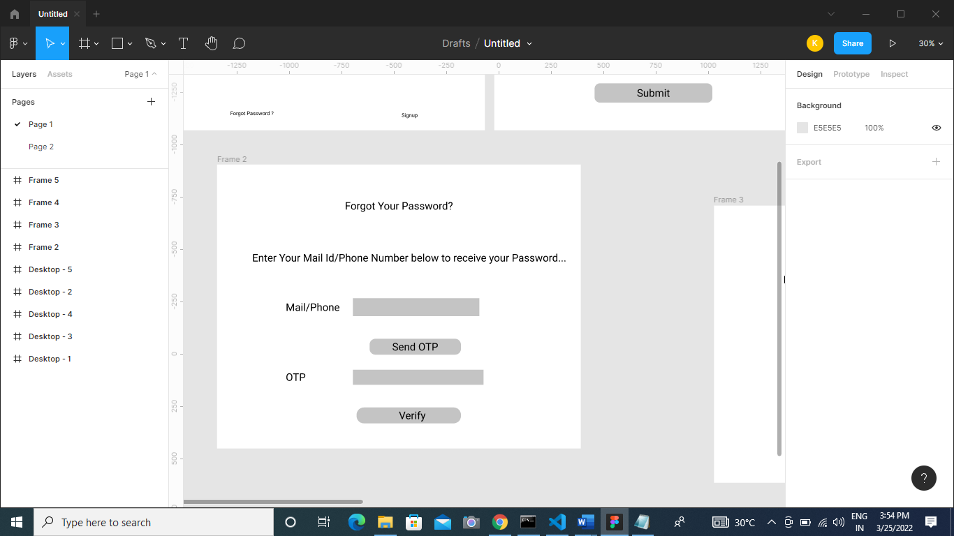

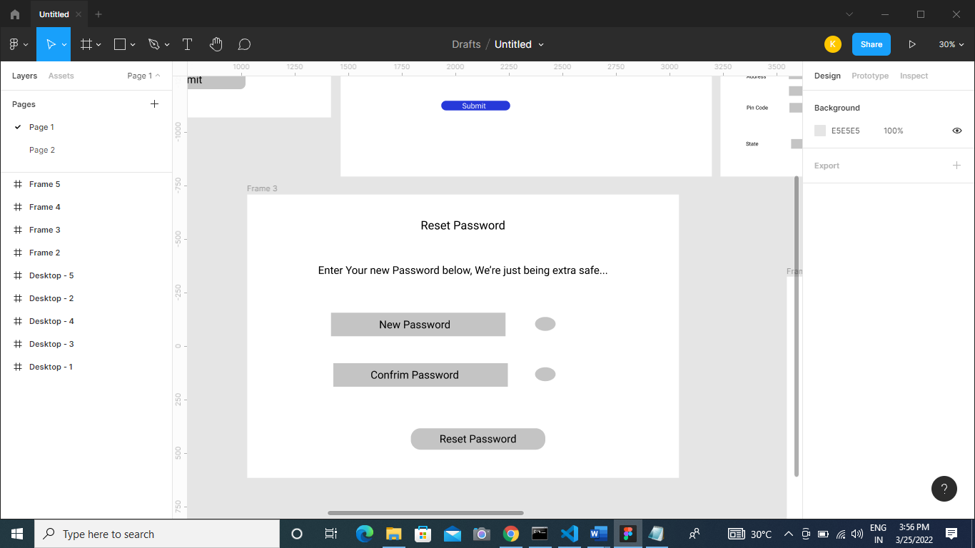

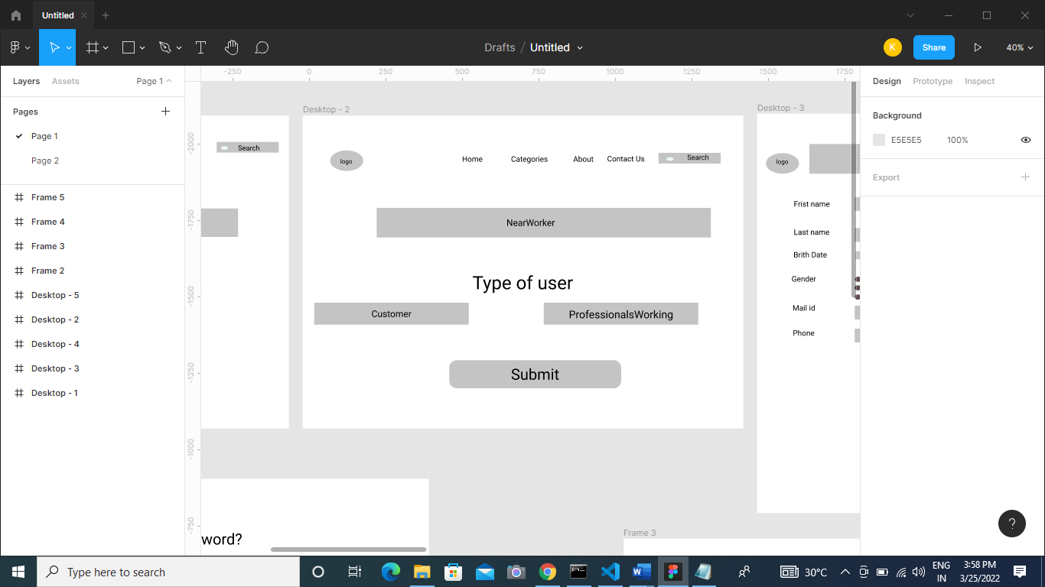

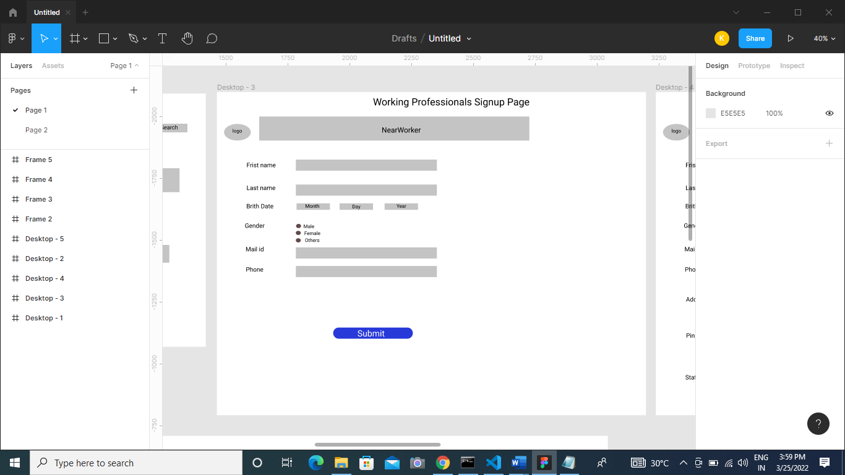

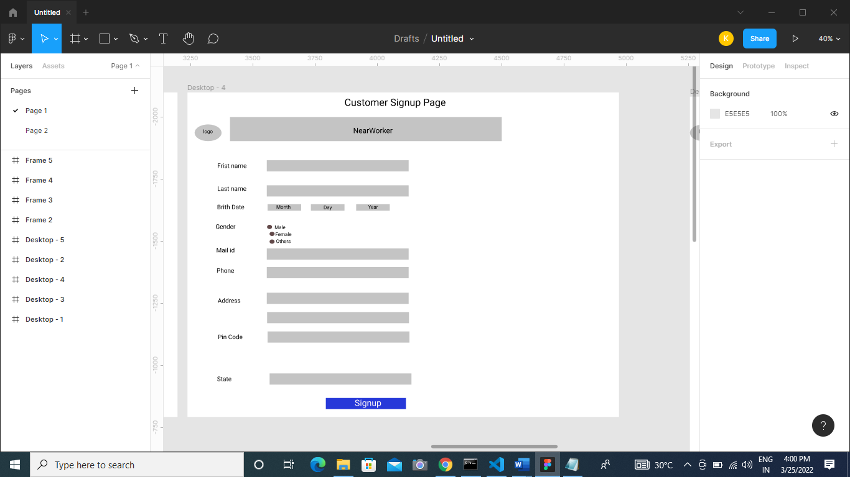

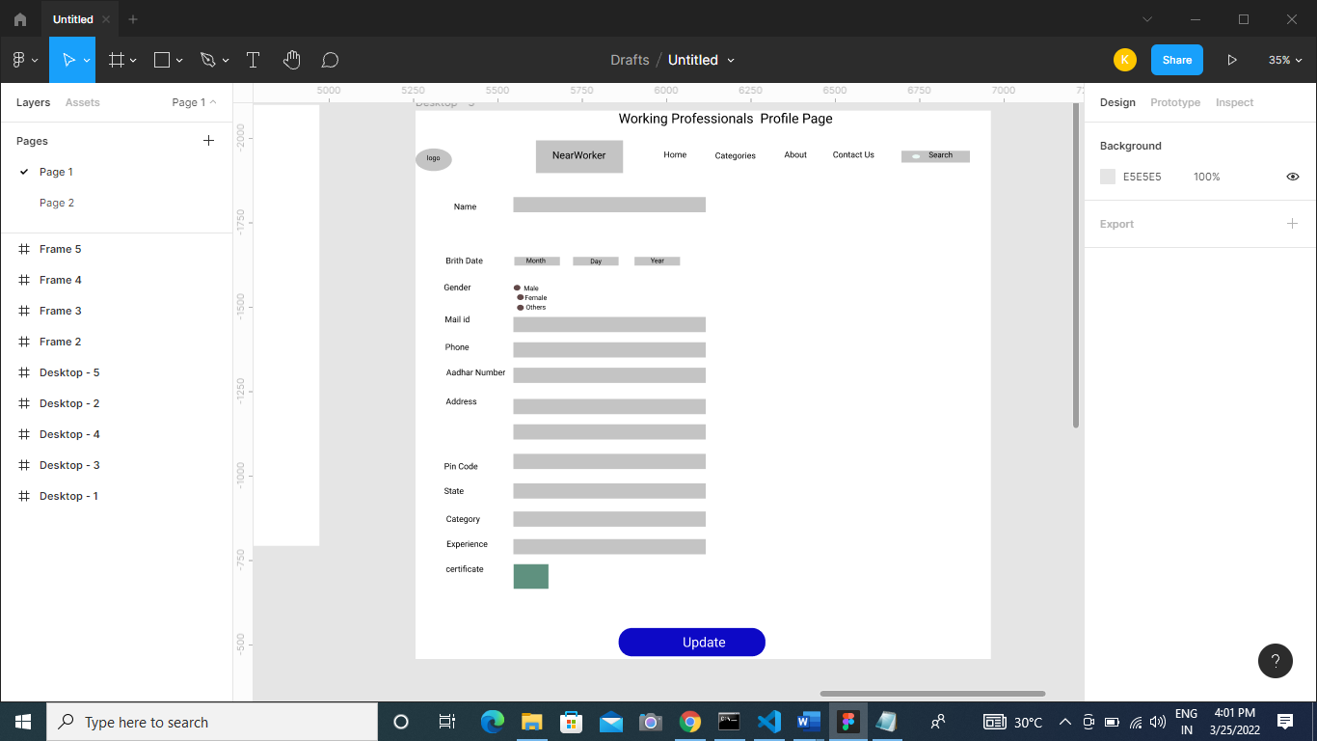

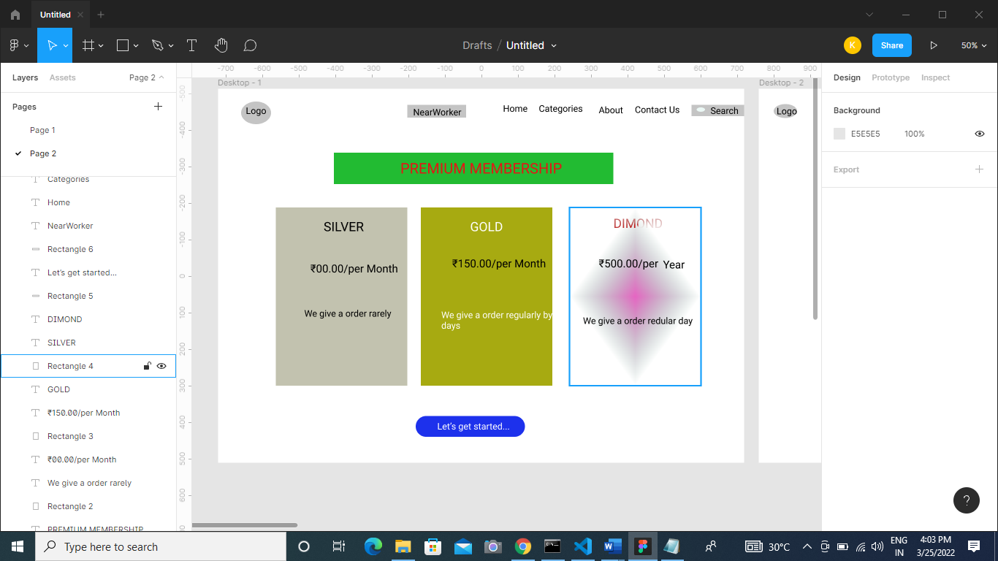

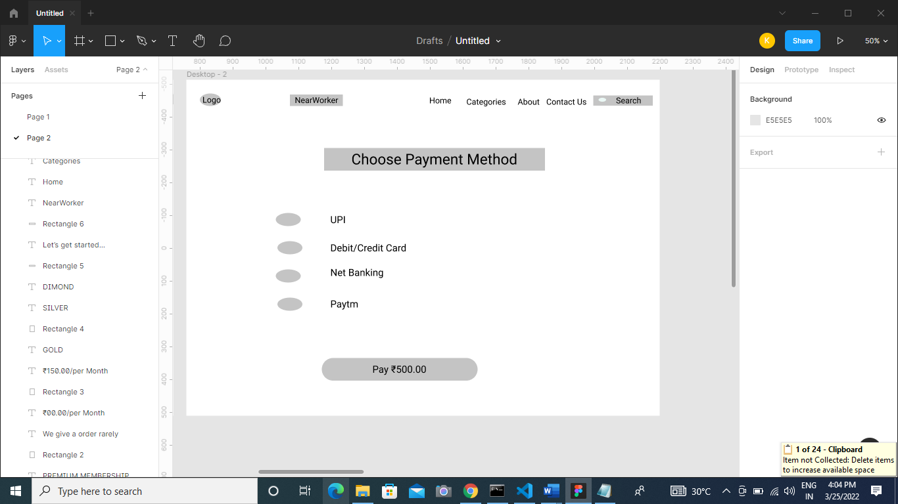

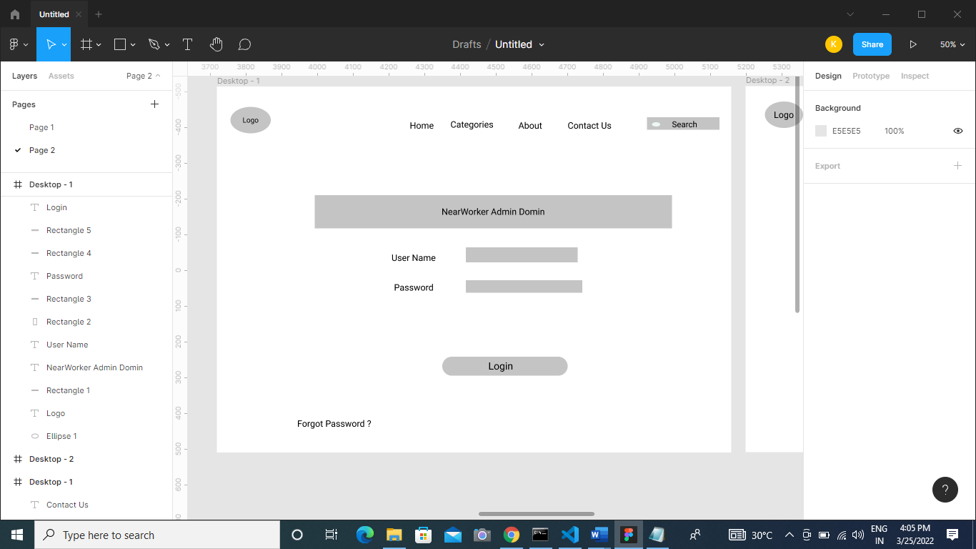

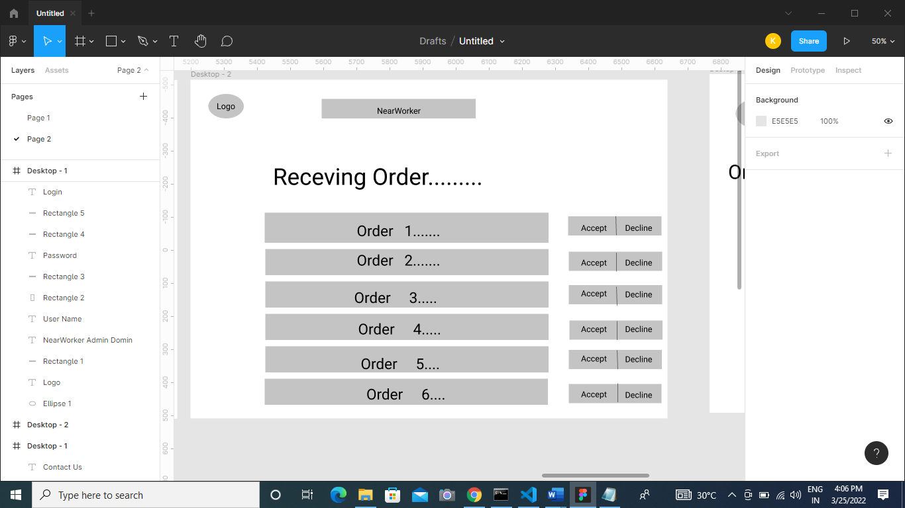

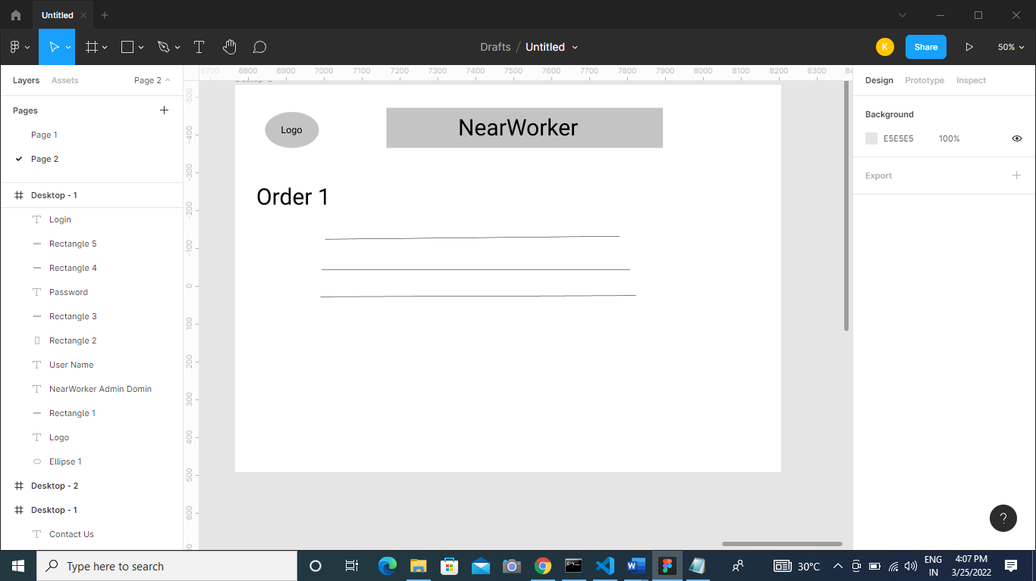

**Database Design:**

**Worker_Registration:-**

1.FirstName

2.LastName

3.Phone_no (PK)

4.Brith Date

5.Gender

6.Email_id

7.Password

**Worker_Category_Master**

1.Category_id

2.Category_name

Category_id Category_Name

001 Caepenter

002 Tv mechanic

003 Ac mechanic

004 Refrigerator mechanic

005 Fan mechanic

**Worker_Profile_info**

1. Worker_Name

2.Worker_Id (PK)

3.Location

4.Experence

5.Certificate

6.Aadhar

7.Starting_time

8.Ending_time

9.Bank Details

**Customer_Regestration:-**

1.FirstName

2.LastName

3.Phone_no (PK)

4.Brith Date

5.Gender

6.Email_id

7.Password

8.Address1

9.Address2

10.Pin code

11.State